Batch: 4
Roll No.: 16010123012

Experiment / Assignment / Tutorial No.: 06

TITLE: Visualize hierarchical and network data
Objective:
To visualize hierarchical and network data.

Expected outcome of Experiment:
CO2 | Detect and understand the stories within datasets and its applications.
_______________________________________________________________
Books/ Journals/ Websites referred:
https://learn.microsoft.com/en-us/power-bi/
_____________________________________________________________________
Background Theory:
This experiment focuses on the visualization of hierarchical and network data to enable effective analysis of structured relationships and interconnections within datasets. Hierarchical data represents information organized in parent–child relationships, where entities are arranged across multiple levels, such as organizational structures, file systems, product categories, or geographical divisions. Network data, on the other hand, represents complex relationships between entities where elements (nodes) are connected through links (edges), commonly found in social networks, transportation systems, communication networks, and recommendation systems.
Visualizing hierarchical data using techniques such as tree diagrams, treemaps, and decomposition trees allows users to understand data distribution, dominance of categories, and drill-down relationships across multiple levels. These visualizations make it easier to identify patterns such as heavily populated branches, imbalanced hierarchies, or dominant subgroups that may not be apparent in tabular data.
Network data visualization employs node-link diagrams and force-directed graphs to illustrate relationships, interactions, and connectivity among entities. By encoding properties such as node size, color, and edge thickness, network visualizations help in identifying influential nodes, clusters, hubs, and isolated components. Such representations are particularly useful for understanding interaction strength, relationship density, and structural dependencies within the dataset.
Visual analysis of hierarchical and network data supports data-driven decision-making and storytelling by transforming complex relational structures into intuitive graphical forms. Interactive visualization features such as drill-down, filtering, and highlighting further enhance exploratory analysis, enabling users to uncover hidden insights, compare relationships, and interpret large-scale structures efficiently. These techniques are widely applied in business intelligence, social media analysis, cybersecurity, supply chain management, and organizational analytics.
Task to be performed on the given dataset:
Visualize Network Data
I. Prepare Your Excel Data
Your Excel data needs a structure that defines relationships. You need at least two columns:
Source: The starting point of a connection (e.g., a customer, a webpage, an employee).
Target: The destination points of a connection (e.g., another customer, another webpage, a manager).
Weight (Optional): A measure to indicate the strength or thickness of the connection (e.g., number of sales, page views)
II. Import the Excel Data into Power BI
Open Power BI Desktop.
Go to the Home tab and select Get Data > Excel.
Browse to your Excel file, select it, and click Open.
In the Navigator pane, select the table(s) or worksheet(s) you want to use, then click Load.
III. Import the Force-Directed Graph Custom Visual
The force-directed graph is a custom visual and is not available by default.
In the Visualizations pane, click on the three dots (...) and select Get more visuals.
In the pop-up window, search for "force" or "network".
Locate the Force-Directed Graph visual (developed by Microsoft) and click Add.
The new visual icon will appear in your Visualizations pane.
IV. Create the Force-Directed Graph
Click the Force-Directed Graph icon in the Visualizations pane to add a blank visual to your report canvas.
Enlarge the visual to an appropriate size.
From the Data pane, drag your fields into the visual's wells in the Visualizations pane:
Drag your Source field into the Source data role.
Drag your Target field into the Target data role.
Drag your Weight field (e.g., sales, views) into the Weight data role. This will make the connecting lines thicker for stronger relationships.
V. Customize the Visual
In the Visualizations pane, select the Format your visual (paint roller) tab.
Explore formatting options such as:
Links: Enable arrows, adjust thickness, and change link color.
Nodes: Change node colors or adjust their size.
Data labels: Turn on/off or change the text size and color.
You can now interact with the graph by dragging the nodes around the canvas to explore the relationships between different entities
Visualize hierarchical data

Step 1: Load the Data
- Open Power BI Desktop.
- Click Home > Get Data > Excel Workbook.
- Select your file and click Load.

Step 2: Select the Treemap Visual
- In the Visualizations pane on the right, look for the icon that looks like a cluster of rectangles.
- Click it to create a blank Treemap on your canvas.

Step 3: Map the Fields
Drag fields from the Data pane into the buckets in the Visualizations pane as follows:
- Category (Group): Drag Region first, then drag Category right below it.
  - Why: This creates a "Drill-down" hierarchy. You will see Regions first, and you can click them to see Categories.
- Values: Drag Sales ($).
  - Why: This determines the size of the boxes. Larger sales = Larger box.
- Details: (Optional) Drag Product here if you want to see individual product boxes without drilling down (caution: this can make the chart very busy).
- Tooltips: Drag Profit Margin (%).
  - Why: When you hover over a box, you will see the profit margin.

Step 4: Add Color Coding (Conditional Formatting)
To make the chart smarter (e.g., darker color = higher profit):
- Go to the Format your visual tab (paintbrush icon).
- Expand Colors > Click the fx button next to "Default color" (or "Colors").
- Format style: Gradient.
- What field should we base this on?: Select Profit Margin (%).
- Minimum: Red (Low profit).
- Maximum: Green (High profit).

How to Interact with it
- Drill Down: Because you put both Region and Category in the "Category" well, you can click the "Drill Down" arrow (single down arrow) in the visual header, then click on "North America" to zoom in and see the specific categories inside North America.
Implementation screenshots:
Hierarchical Data
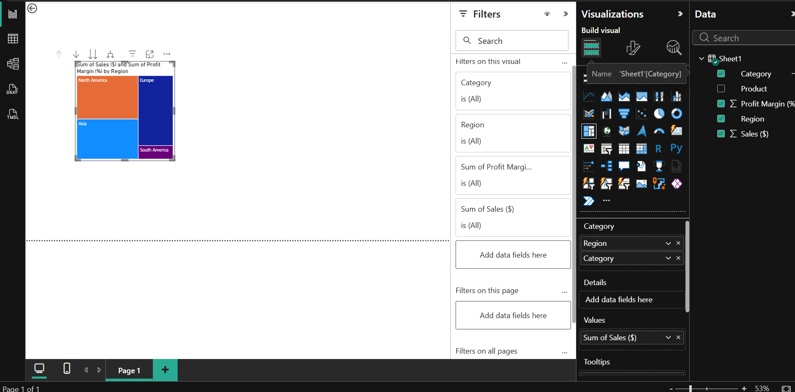
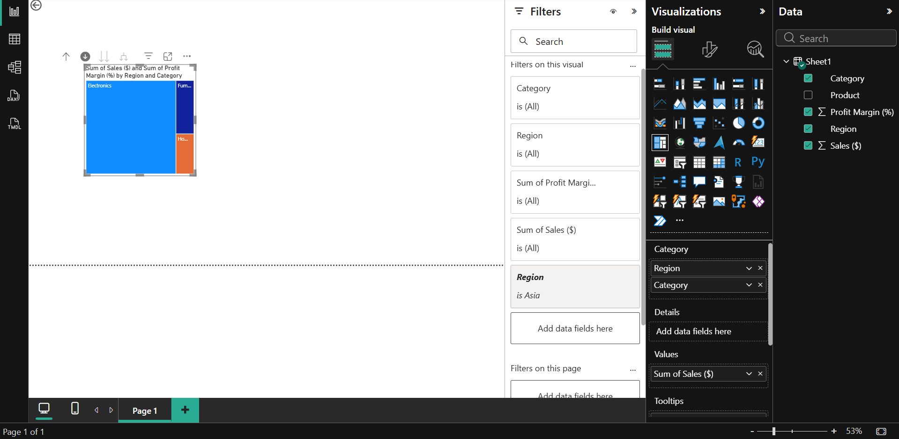
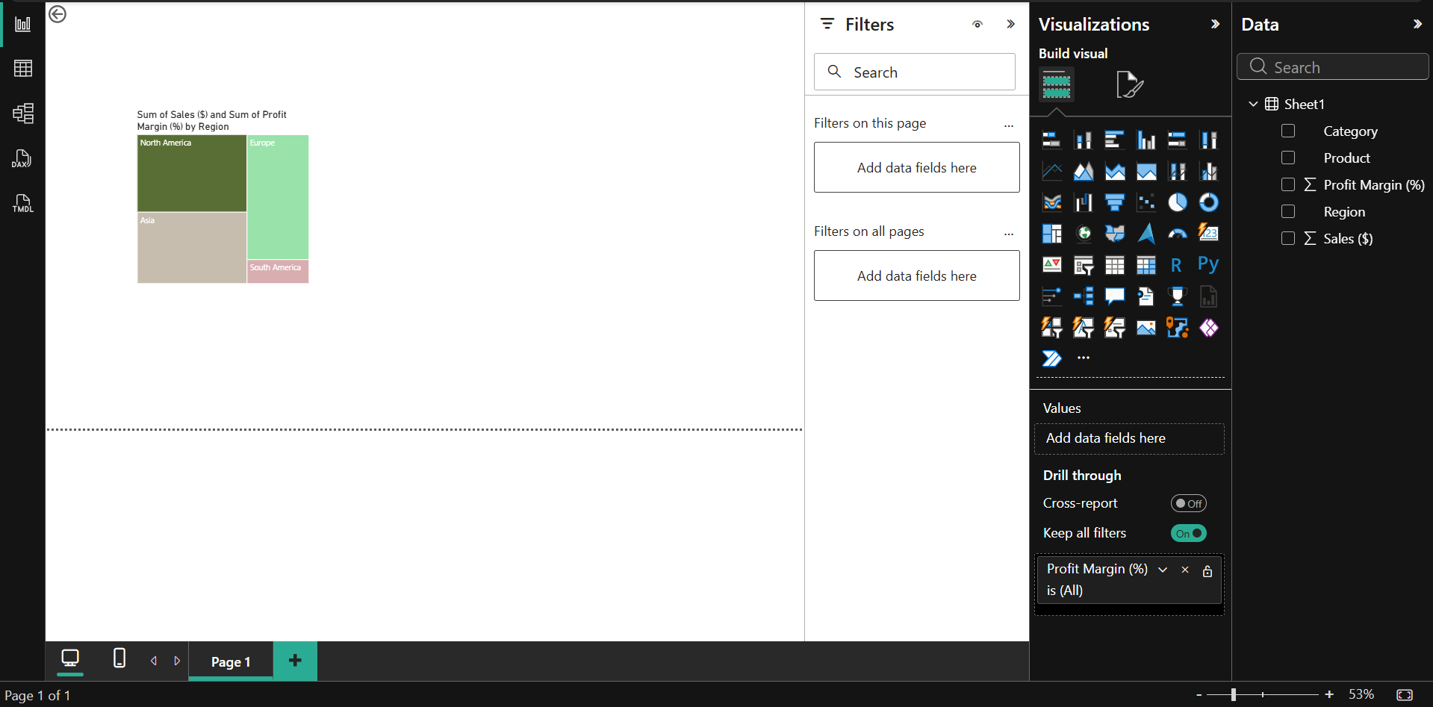
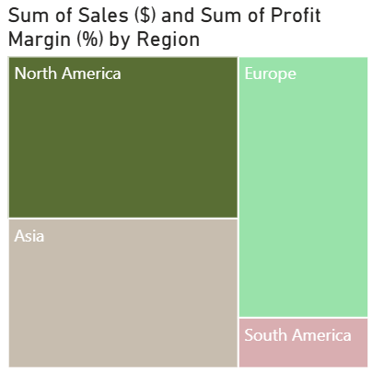
Analysis: The treemap clearly shows how sales are distributed across different regions and categories. North America stands out with the largest area, indicating that it has the highest sales, while South America contributes the least. By using the drill-down feature, it becomes easier to see which categories perform best within each region, with categories like Technology often leading. The differences in profit margins across regions also highlight how performance varies, even when sales are high. Overall, the visualization makes it easy to understand which regions and categories are most important in the dataset.
Network Data
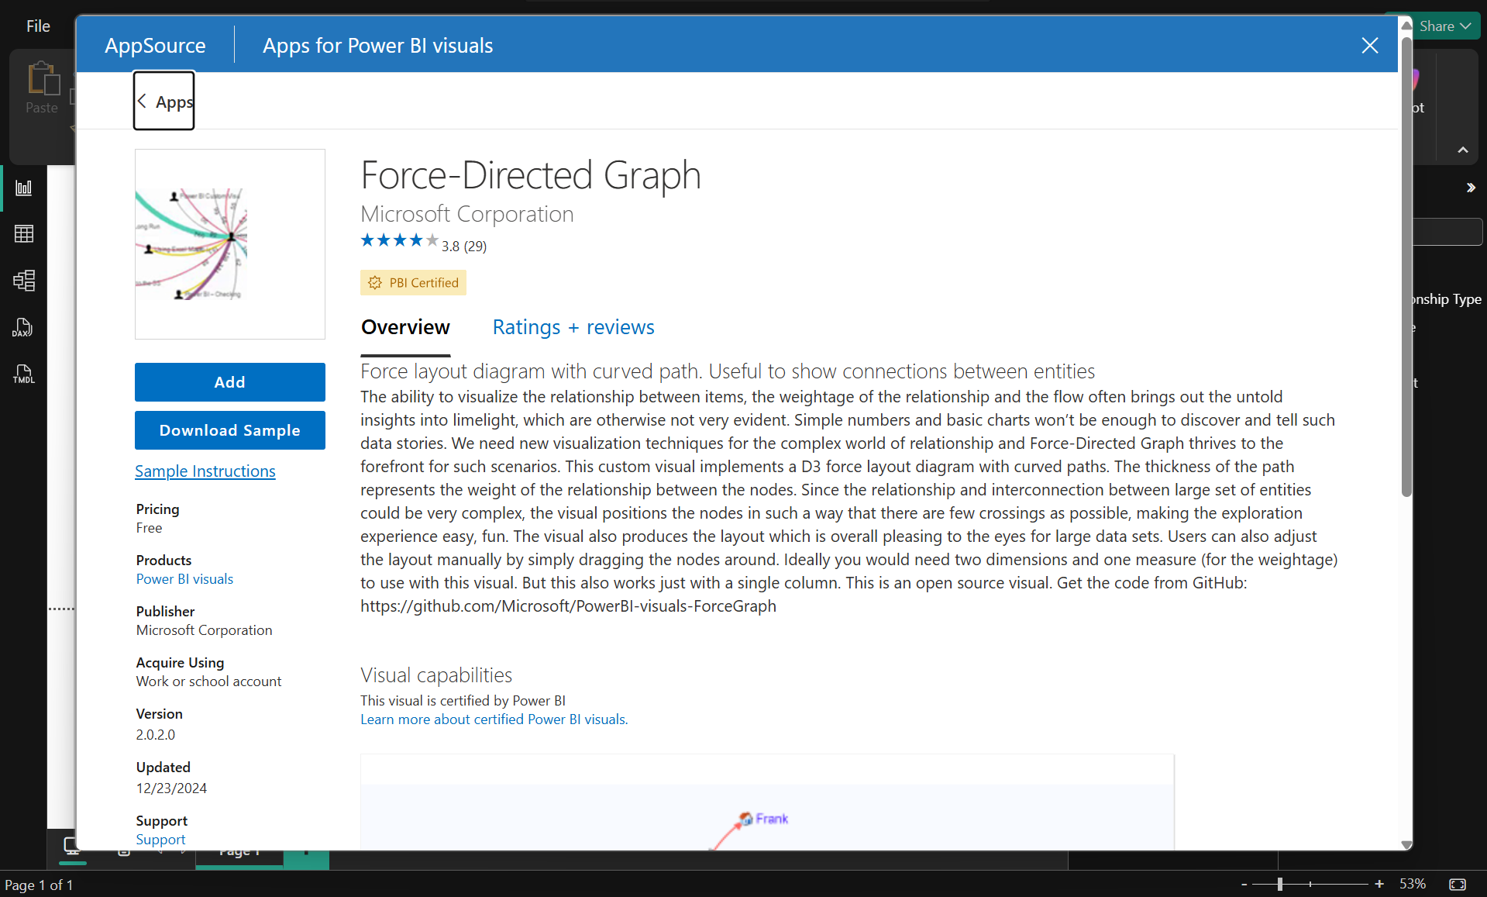
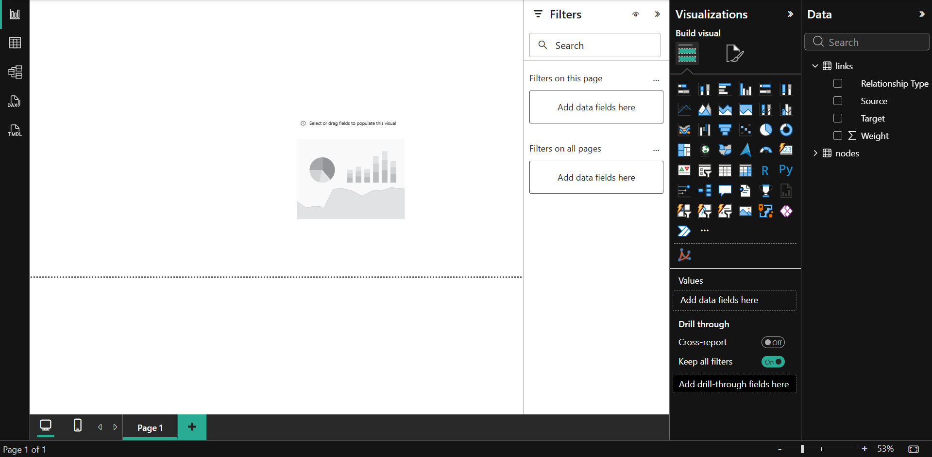
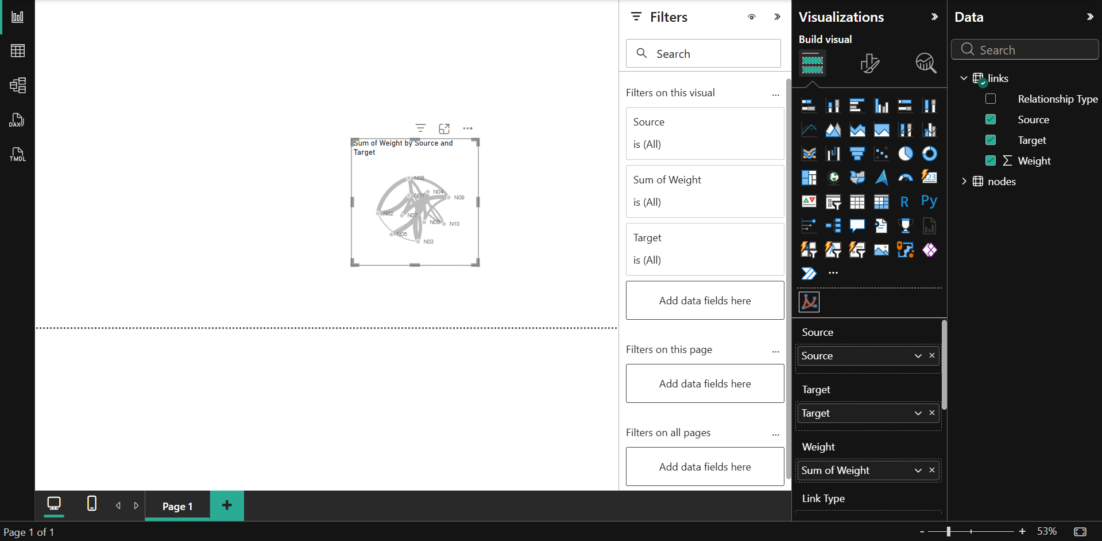
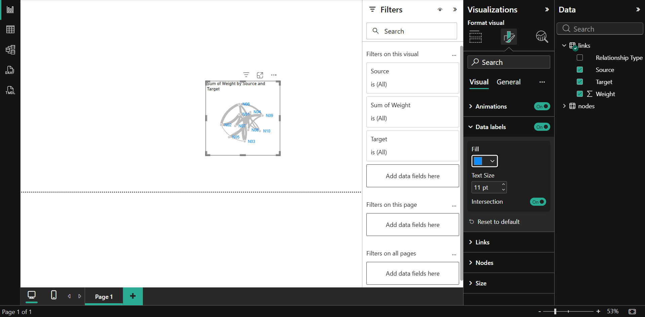
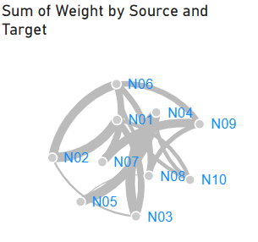

Analysis: The network graph shows how different nodes are connected to each other. Some nodes, like N01 and N06, have more connections, which means they play an important role in the network. The thickness of the lines shows how strong the relationships are. Groups of closely connected nodes can also be seen, which may represent teams or related activities. Different types of relationships, such as strategy, technical, and collaboration, show that there are various kinds of interactions in the network. Overall, the graph makes it easy to understand how everything is connected and which nodes are more important.

Conclusion:
In this experiment, hierarchical and network data were successfully visualized using Power BI to understand structured relationships and interconnections within the dataset. Treemap visualization was used to represent hierarchical data, enabling easy identification of dominant categories and drill-down analysis across different levels. Network data was visualized using a force-directed graph, which helped in identifying key nodes, connections, and relationship strength within the network. These visualizations made complex data structures easier to interpret and analyze. Overall, the experiment enhanced understanding of hierarchical and network data representation and demonstrated how such visualizations support better insight generation and decision-making.
Post Laboratory Questions
- Why are tree and treemap visualizations suitable for hierarchical datasets?
Tree and treemap visualizations are suitable for hierarchical datasets because they represent data in a structured parent–child format across multiple levels. Treemaps use nested rectangles to show how categories are divided into subcategories, making it easy to understand distribution and relative proportions. These visualizations also support drill-down functionality, allowing users to explore data at different levels, which makes them effective for analyzing hierarchical relationships.
- What challenges arise when visualizing large networks?
Visualizing large networks can be challenging due to issues such as clutter, overlapping nodes, and excessive connections, which make the graph difficult to interpret. As the number of nodes and edges increases, readability decreases, and identifying meaningful patterns becomes harder. Performance can also be affected, leading to slower rendering. Additionally, distinguishing important nodes or relationships becomes difficult without proper filtering or clustering techniques.
- In which scenarios would a network visualization be preferred over hierarchical visualization?
Network visualization is preferred when the data represents complex relationships between entities that are not strictly hierarchical. It is useful in scenarios such as social networks, communication systems, transportation networks, and recommendation systems, where entities can have multiple connections. Unlike hierarchical visualization, network graphs allow the analysis of interaction patterns, clusters, and connectivity between nodes.

